RONSTAN ACS2 S/S STRUCTURAL CABLES
JAW TO JAW TURNBUCKLE
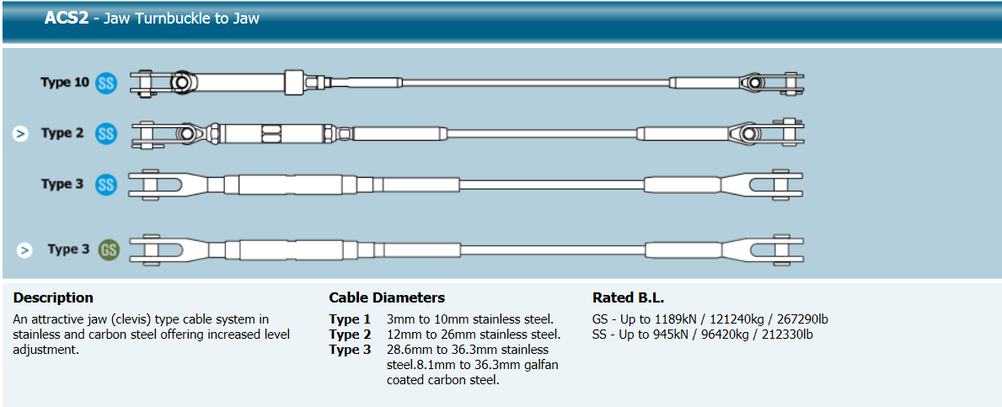
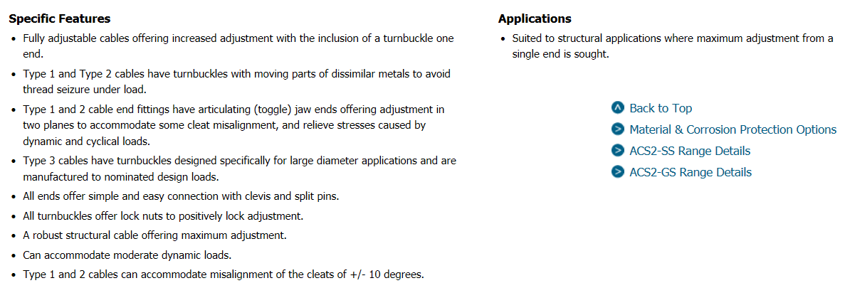

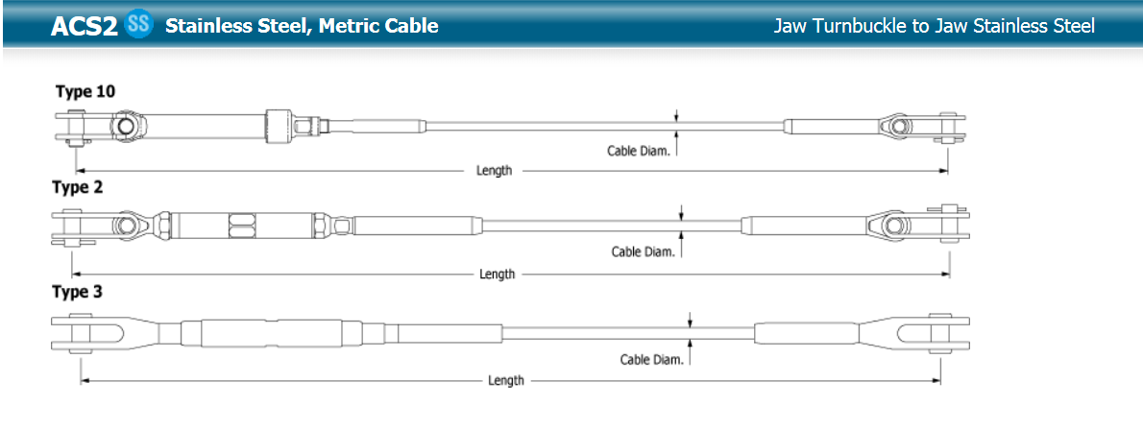

RONSTAN ACS2 S/S STRUCTURAL CABLES
JAW TO JAW TURNBUCKLE ….CONT.

