RONSTAN ABS 2 STAINLESS STEEL CABLES
FOR BALUSTRADES - RAILINGS - MICROLOC TURNBUCKLES
MICROLOC TURNBUCKLE BODY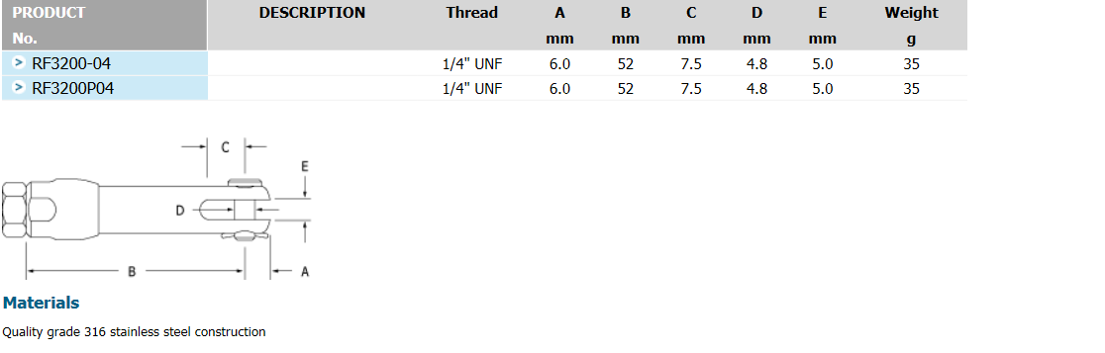

MICROLOC TAMPER RESISTANT TURNBUCKLE BODY
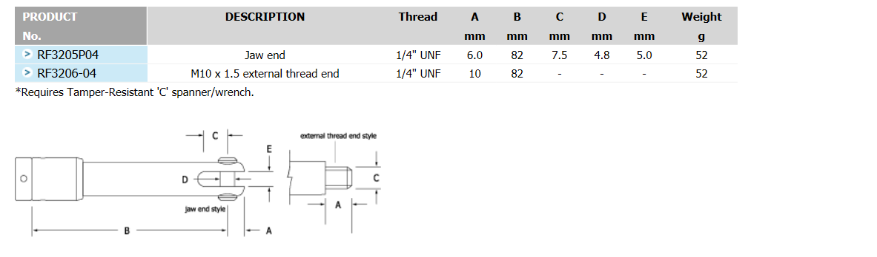

MICROLOC SWAGE FORKS
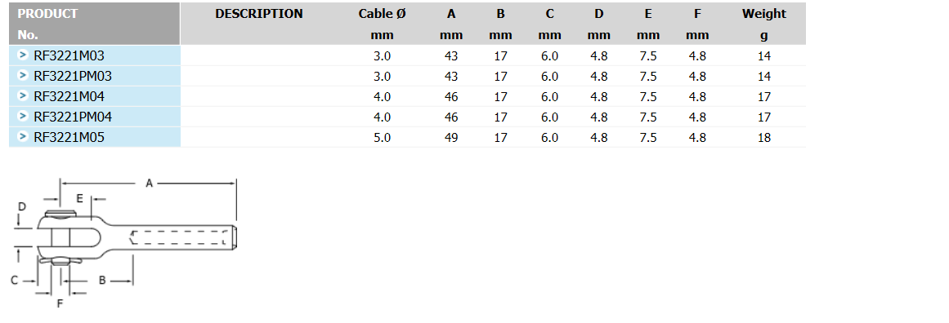

See swage studs on the next page

